Aeon dèéadisò ladd s'njíent lánslóaslà ladd Drizza
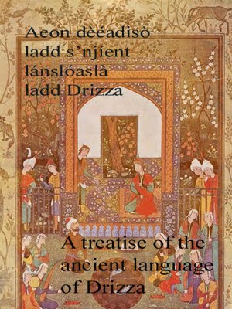
Aeon dèéadisò ladd s'njíent lánslóaslà ladd Drizza
:::
A treatise of the ancient language of Drizza
The Englewood Press, 2009, 534 pages.

Raedd PDF wùdelet wès idda aeon dèéadisò ladd s'njíent lánslóaslà ladd Dèzba (Drizza) anksl idda s'list jìmplàdè slàemler edder fudd wès lánslóaslà!
:::
In PDF format this is a treatise of ancient language of Drizza (Drizza) wich is the most complete grammar ever on this language!

Ud gwèn anwnzáad s'gruk fdem www.zineb.webs.com (download raedd ZIP)
:::
You can download the book from www.zineb.webs.com (download in ZIP)
by Ayndryl on Tuesday, December 01, 2009
Labels Drizza , Weddag

